**Solution for Practice Questions on Sets and Functions**

1. Which of the following is not a Set?

* Organization of utensils in the kitchen
* Shopping malls as there will be separate and well defined portions for different kind of things
* Playlists in your mobile are organized according to genres
* Collection of beautiful songs

**Explanation**: Collection of beautiful songs is not well defined. What is beautiful for me as a song may be your most disliked song!

1. An empty set can contain “0” as one of the elements

* True
* False
* Cannot say anything

**Explanation**: False. Empty set does not contain anything!

1. If U = {1, 3, 5, 7, 9, 11, 13}, then which of the following are subsets of U.

* B = {2, 4}
* A = {0}
* C = {1, 9, 5, 13}
* D = {5, 11, 1}

**Explanation**: All the elements in the Subset should contain elements only from the main set

1. Which of the following sets is a universal set for the other four sets?

* Set of even natural numbers
* Set of odd natural numbers
* Set of natural numbers
* Set of negative numbers
* Set of integers

**Explanation**: Integers is a universal set which contains natural numbers and whole numbers. Refer Slide pertaining to Subsets for more explanation

1. If A = {2, 3, 4, 5}     B = {4, 5, 6, 7}     C = {6, 7, 8, 9}     D = {8, 9, 10, 11}, find

A U B, B U C, (A U B) U C

**Explanation**: A U B = {2, 3, 4, 5, 6, 7} ; B U C = {4, 5, 6, 7, 8, 9}

To find(A U B) U C: First perform A U B. Union the result of this with C

A U B = {2, 3, 4, 5, 6, 7} ; (A U B) U C = {2, 3, 4, 5, 6, 7} U {6, 7, 8, 9} = {2, 3, 4, 5, 6, 7, 8, 9}

1. If A = {4, 6, 8, 10, 12} B = {8, 10, 12, 14} C = {12, 14, 16} D = {16, 18}, find

A ⋂ B, B ⋂ C, B ⋂ D, (A ∪ D) ∩ (B ∪ C)

**Explanation:** A ⋂ B = {8, 10, 12} ; B ⋂ C = {12, 14} ; B ⋂ D = {} ;

(A ∪ D) ∩ (B ∪ C) : To find this, first find A U D , then find B U C and then find the intersection of these two.

So (A ∪ D) ∩ (B ∪ C) = {4, 6, 8, 10, 12, 14} ∩ {8, 10, 12, 14, 16} = {8, 10, 12, 14}

1. If A = {1, 2, 3, 4, 5} what is the cardinality of A

* 1
* 2
* 4
* 5

**Explanation**: Cardinality is the number of elements in the set

1. Let Color C = {R, B, G} and Size S = {S, M, L}. Find the Cartesian product of C and S

**Explanation**: Cartesian product of C and S is denoted by CxS. The number of elements in the Cartesian product is the product of number of elements in each individual sets

CxS ={RS, RM, RL, BS, BM, BL, GS, GM, GL}

1. Which of the below lists is equal to the list L = {1, 2, 3}

* A = {1, 3}
* B = {2, 1, 3}
* C = {3}
* None of the above

Explanation: Remember, Set {1, 2, 3} = Set{2, 1, 3}. Order matters in List. Order does not matter in set

1. See the diagram below

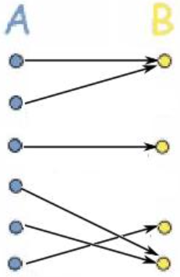

The function from Set A to B is:

* A general function
* Injective but not Surjective
* Surjective but not injective
* Bijective

**Explanation:** Please refer to slides on types of functions

1. See the diagram below:

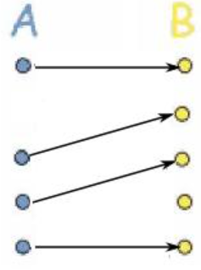

The function from Set A to B is:

* A general function
* Injective but not Surjective
* Surjective but not injective
* Bijective

**Explanation**: Please refer to slides on types of functions

1. If f(x) = 3x − 1 and g(x) = x2, then what is (f ° g)(x)?

* x2 -1
* 3x2 -1
* 9x2 -1
* x2 (3x-1)

**Explanation:** This is a problem of composition. (f ° g)(x) = 3**x2**-1. x2 marked in green is the g(x) embedded inside the f(x)

1. If f(x) = 1/x for x ≠ 0, then what is (f ° f)(x)?

* X
* 1
* x2
* 1/ x2

**Explanation:** This is a problem of composition. (f ° f)(x) = 1/(1/x) = x. here we have embed f(x) inside of f(x).

1. f and g are both defined on the set of real numbers and c is a constant  
   f(x) = cx − 3  
   g(x) = cx + 5  
     
   If (f ° g)(x) = (g ° f)(x) for all values of x, what is the value of c?

* 0
* 1
* 4
* 8

**Explanation:**

(f ° g)(x) = f(g(x)) = f(cx + 5) = c(cx + 5) − 3 = c2x + 5c − 3

(g ° f)(x) = g(f(x)) = g(cx − 3) = c(cx − 3) + 5 = c2x − 3c + 5

If (f ° g)(x) = (g ° f)(x) for all values of x, then

c2x + 5c − 3 = c2x − 3c + 5

⇒ 5c − 3 = -3c + 5

⇒ 8c = 8

⇒ c = 1